<SHOPAA>

Software Architecture Document

Version <1.0>

Revision History

| **Date** | **Version** | **Description** | **Author** |
| --- | --- | --- | --- |
| <dd/mmm/yy> | <x.x> | <details> | <name> |
|  |  |  |  |
|  |  |  |  |
|  |  |  |  |

Table of Contents

1. Introduction 4

2. Architectural Goals and Constraints 4

3. Use-Case Model 4

4. Logical View 4

4.1 Component: abc 4

5. Deployment 4

6. Implementation View 4

Software Architecture Document

# Introduction

# Architectural Goals and Constraints

# Use-Case Model

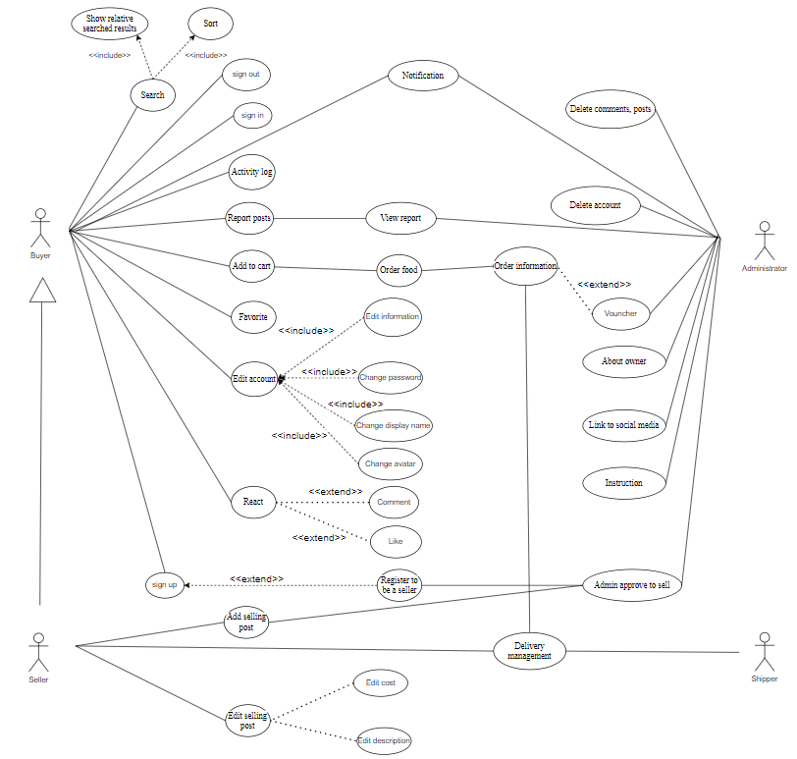

# Logical View

## Component: abc

# Deployment

# Implementation View